Number and symbol cards
m | 1 | 2
3 | 4 | 5
6 | 7 | 8
9 | 10 | +
– | = | a

Pyramids and equations (1)
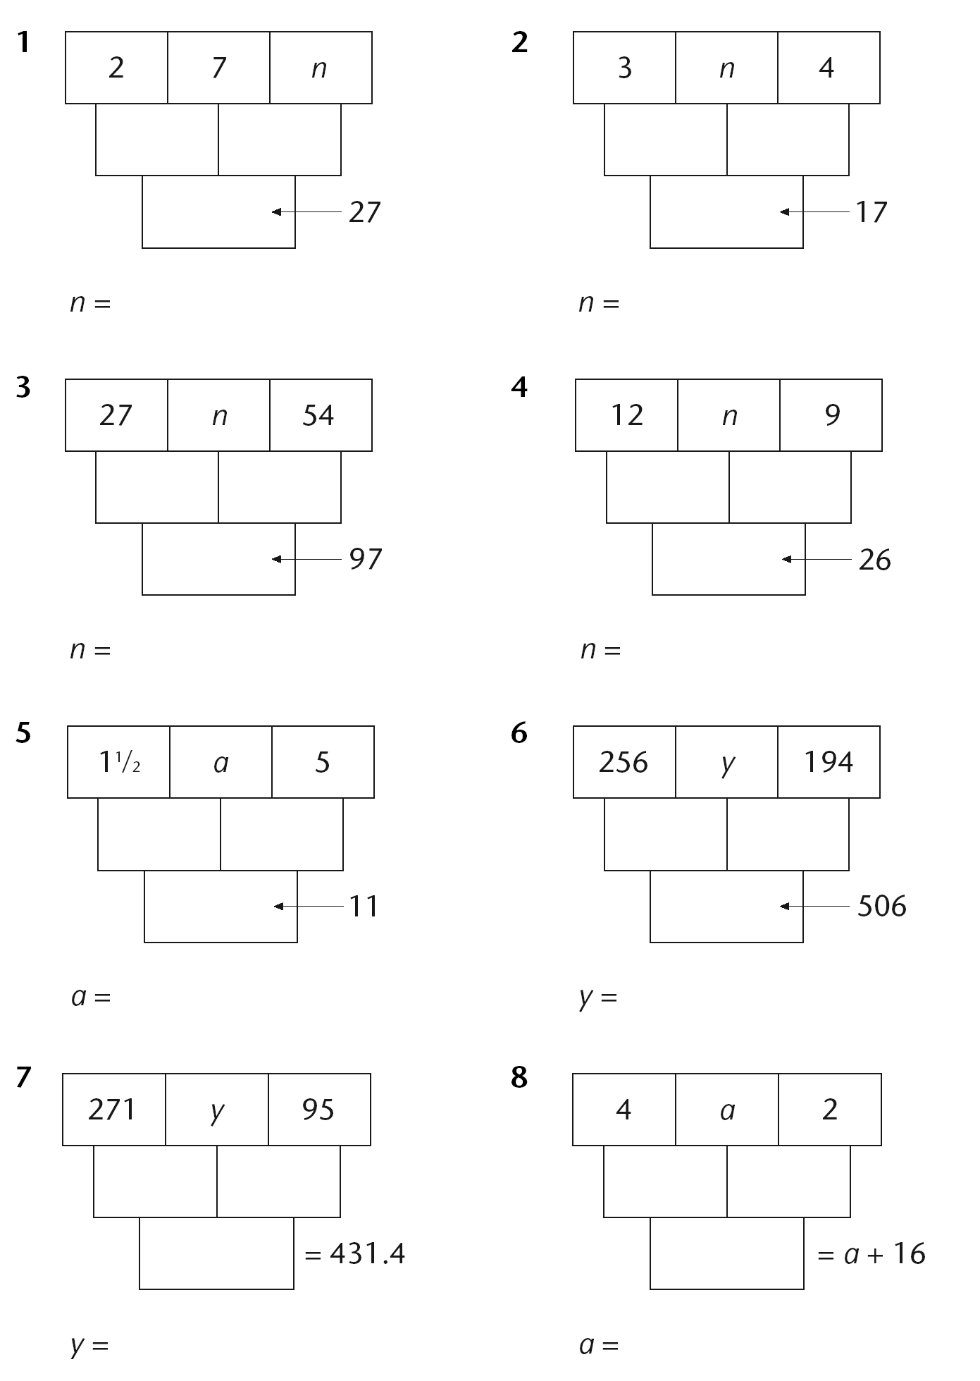
Pyramids and equations (2)
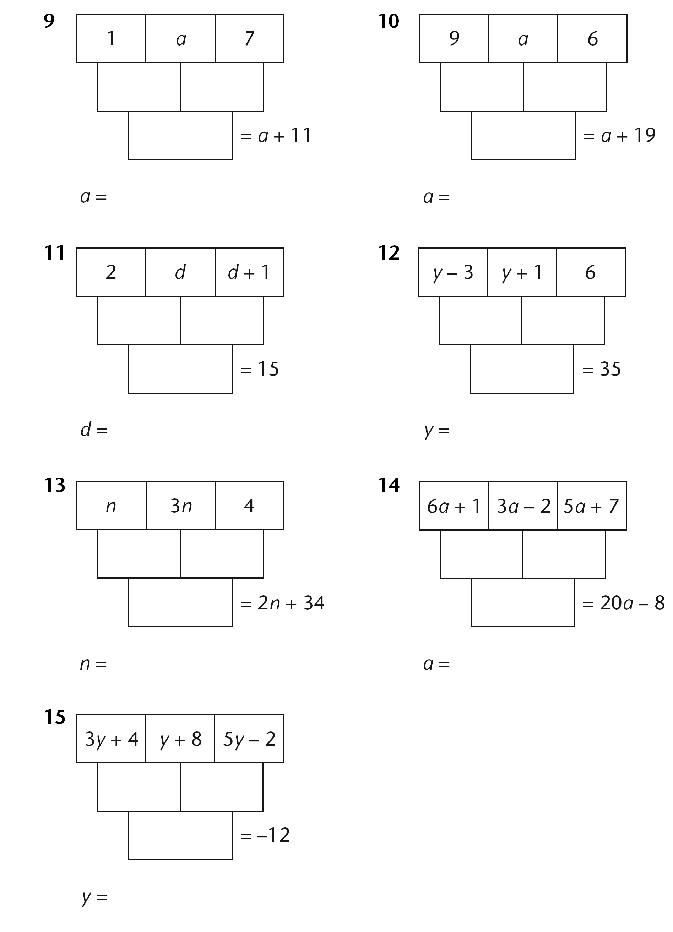
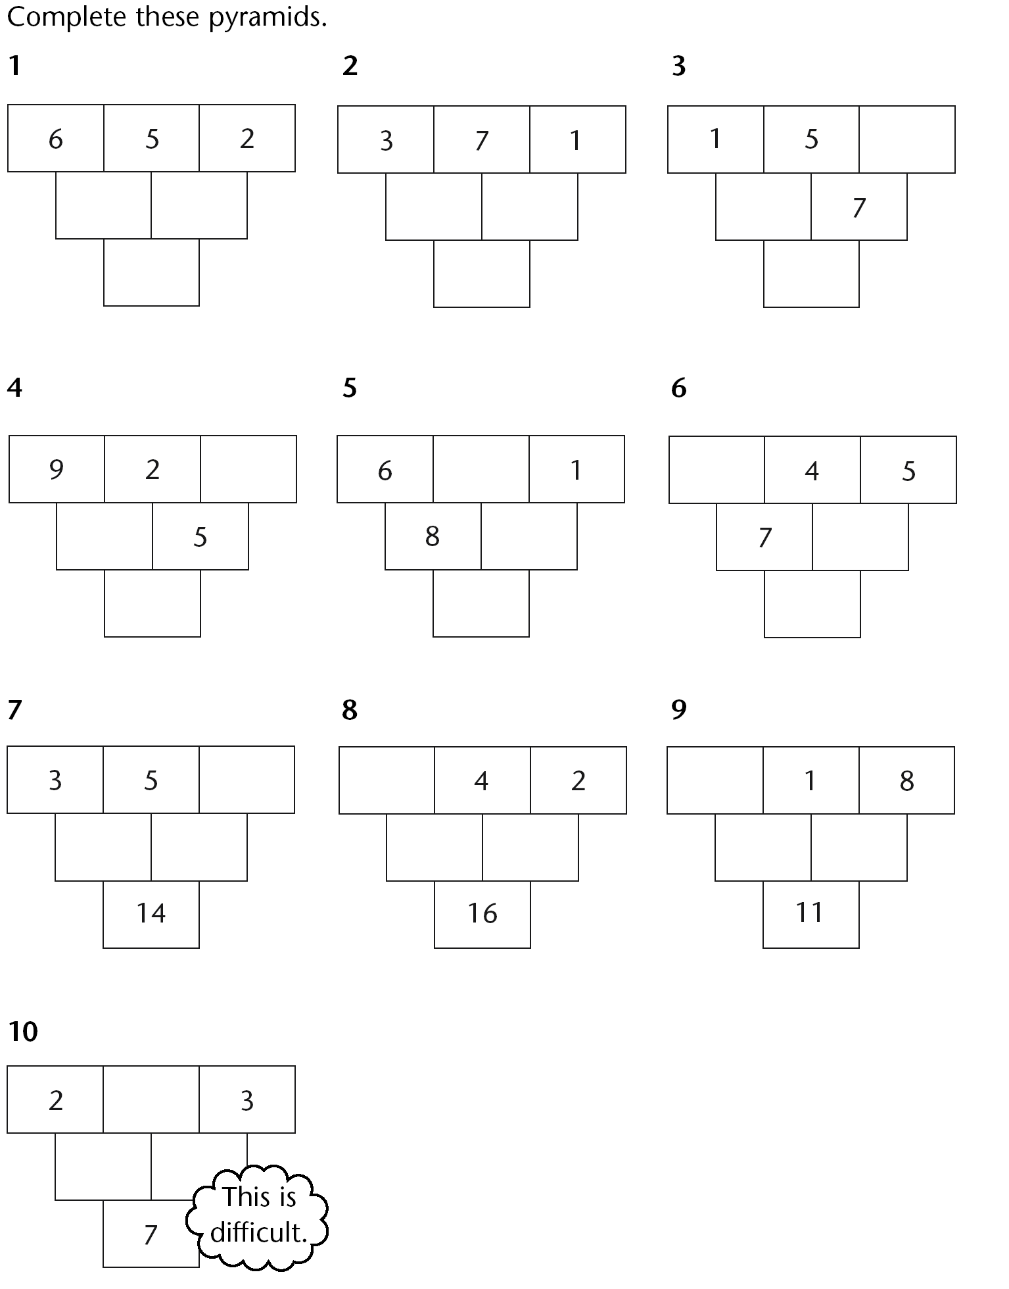
Pyramids (1)

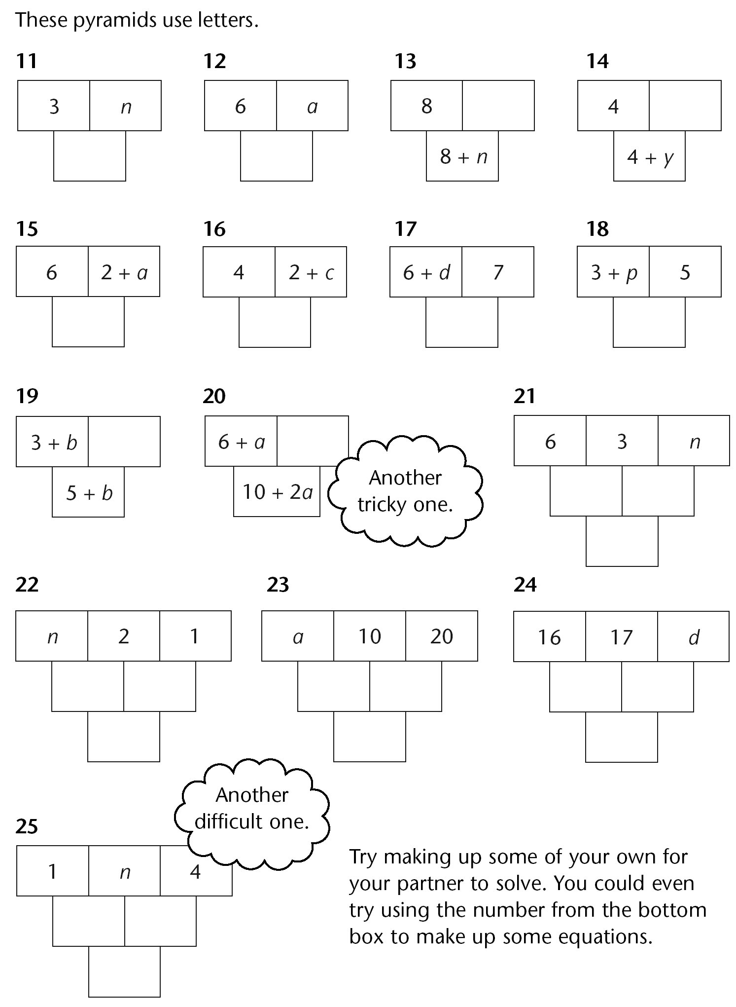
Pyramids (2)

There are 376 stones in three piles.
The second pile has 24 more stones than the first pile.
The third pile has twice as many stones as the second pile.
How many stones are there in each pile?

Menu 1
Pasta ..............................................................…... 55p
Pasta and salad .................................................... 75p
Pasta, salad and milk ..............................…........... 90p
Pasta and milk ........................................................
Salad and milk .......................................................

Menu 2
Egg ........................................................................ 30p
Egg and toast ........................................................ 60p
Egg, tomato and toast ........................................... 70p
Egg, tomato, beans and toast ................................ 90p
Tomato, beans and toast ........................................
Beans and toast ......................................................

Menu 3
Curry .................................................................. £2.00
Curry and rice .................................................... £2.50
Curry and bhaji ................................................... £2.40
Curry and kebab ................................................. £2.80
Curry, rice and bhaji ........................................…
Curry, rice, bhaji and kebab ............................…
Kebab and rice ................................................…

Write a number in the box at the end of
each equation to make it correct.

- 400 + 300 = 600 +
- 14 + 6 = 4 +
- 23 + 2 = 13 +
- 37 – 20 = 27 –
- 40 + 17 = 30 +
- 40 – 17 = 30 –
- 6 × 5 = 3 ×
- 40 × 10 = 4 ×
- 7000 ÷ 100 = 700 ÷

Find the number, t, that will give the same value for the central cell using either the upper or lower pyramid.
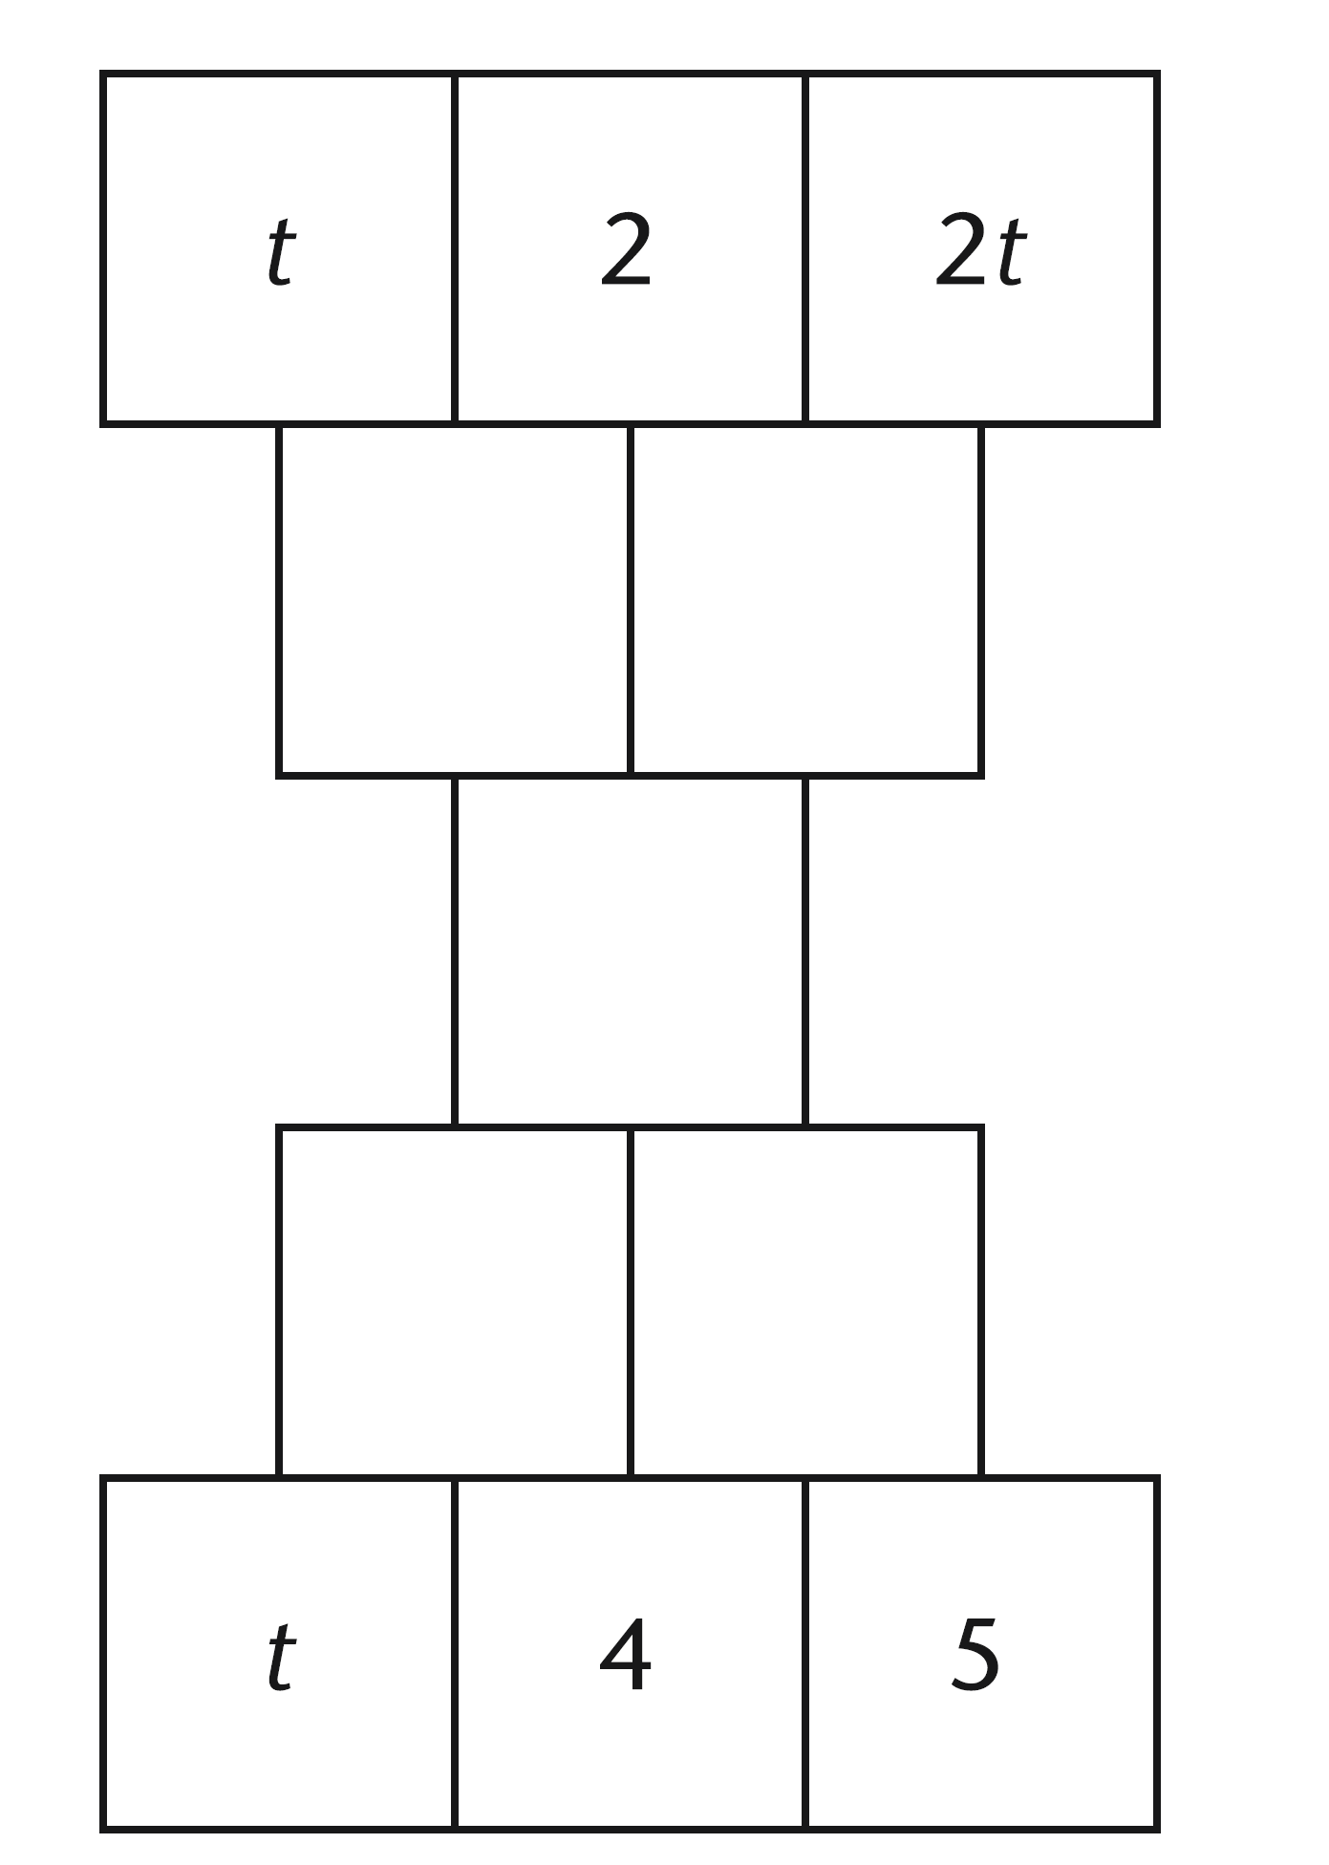

Rule: Add adjacent expressions to give the result in the cell above (or below for the upper pyramid).

Use a number line to solve these equations.

1 2x + 11 = 17

2 m + 9 = 2m + 4

3 5g + 6 = 11 + 3g

4 4x + 5 = x + 2.4 + 2x

5 2r + 15 = 3(r + 1)

Homework

Use a number line to solve question 1 and then spend 10 minutes on questions 2 and 3.

1 4x + 7 = 2x + 13

2 2x + 3 = 2x + 7

3 2x – 1 = x + 9

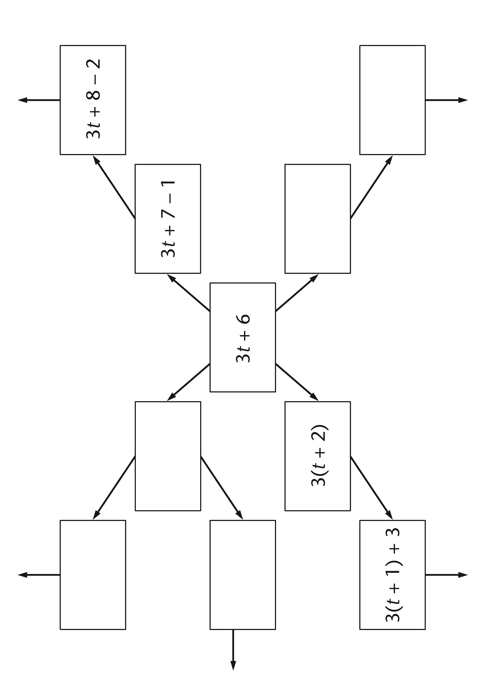

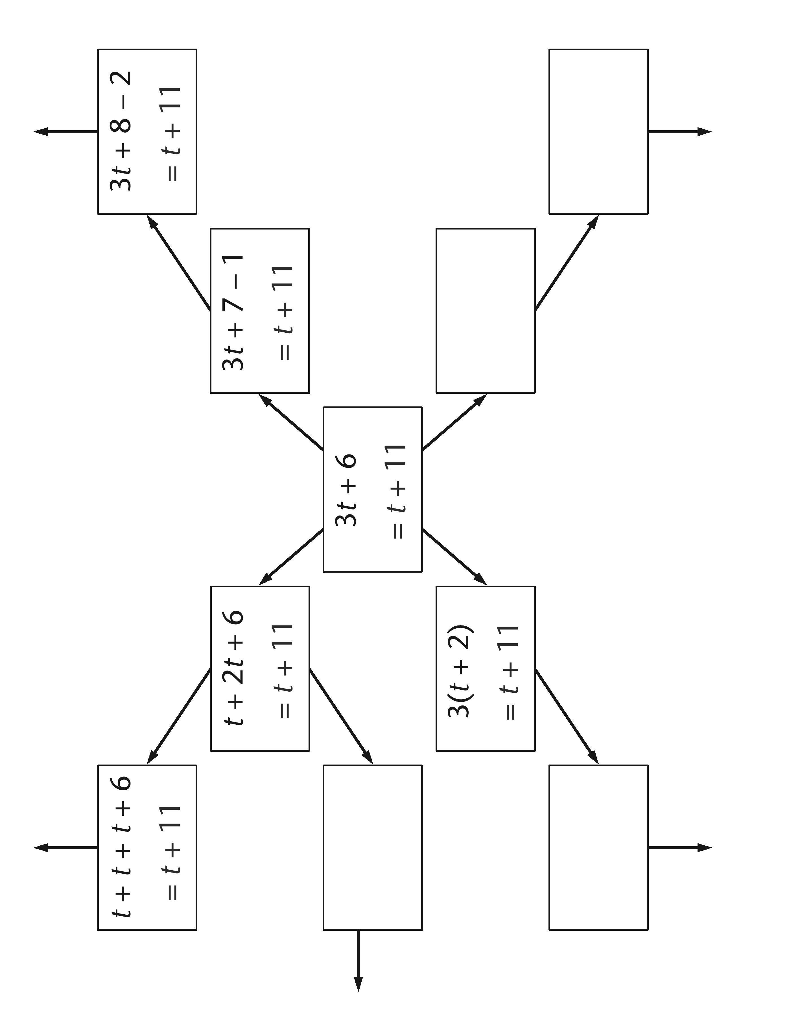

Use the matching method to solve these equations.
Record your working clearly.
1 2x + 7 = 19
2 2m + 9 = 3m + 4
3 2y – 5 = y + 7
4 4t + 5 = t + 2.4 + t
5 17 = 2(4d – 2)

Each of the expressions below has the same value as 6 – 8x.
A plus or minus sign is hidden by each sticky note.
What is the hidden sign?
2 4 (1 2x)

How do you know? Think! Do you have to multiply and simplify each expression or is there a quicker way of knowing?
10 4 (1 2x)
4 2 (1 4x)
8 2 (1 4x)
6 (1 x) 2x
6 (1 x) 14x
2 (3 2x) 4x
2 (3 2x) 12x
3 (2 x) 15x
3 (2 x) 111x

Have you thought about a quicker way?
Talk about it – share it with your partner!
2 (3 x) 16x
2 (3 x) 110x
Which equations are linear?

$$y=5−\frac{x}{4}$$ | $$y+2x−7=0\text{.}3$$
$$y=x^{2}$$ | $$y=\frac{3}{x}$$
$$y+x=x+2$$ | $$y=−0\text{.}6x−6\text{.}4$$

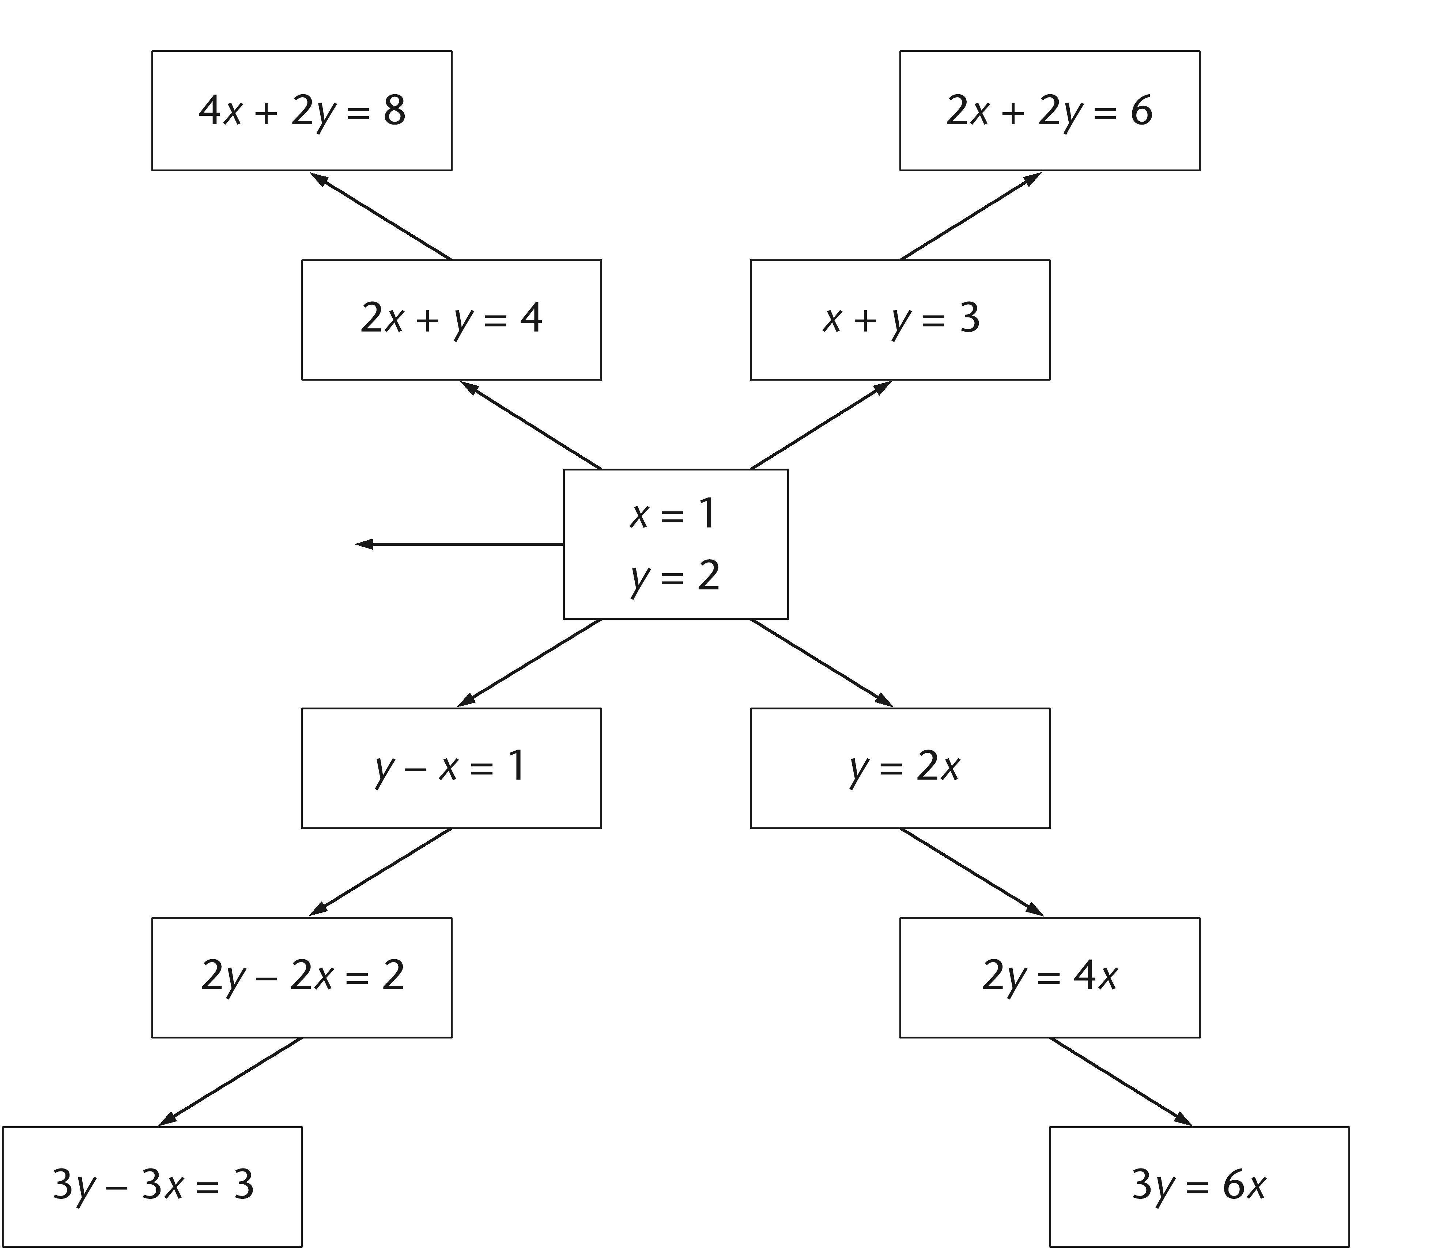
Equation tree

